Overview
Landscape Systems
An investigation of a River System from Source to Mouth
A Study of the physical characteristics of the River Chalmadale and its main tributary, the Easan.
Although the study of a river system from source to mouth is no longer standard within A-Level, a number of our groups consider that it still provides the best example of how to carry out a fieldwork investigation & therefore we are happy to offer it as a study option.
Student will collect data for width, depth, wetted perimeter, velocity, channel roughness, bedload size, bedload roundness, and turbidity. This data will be collated in a table, which can then be used later in the evening follow-up & back at school. During their journey down the river, students can also take note of the changing landscape and fluvial landforms and make appropriate notes and field sketches.
Evening follow up

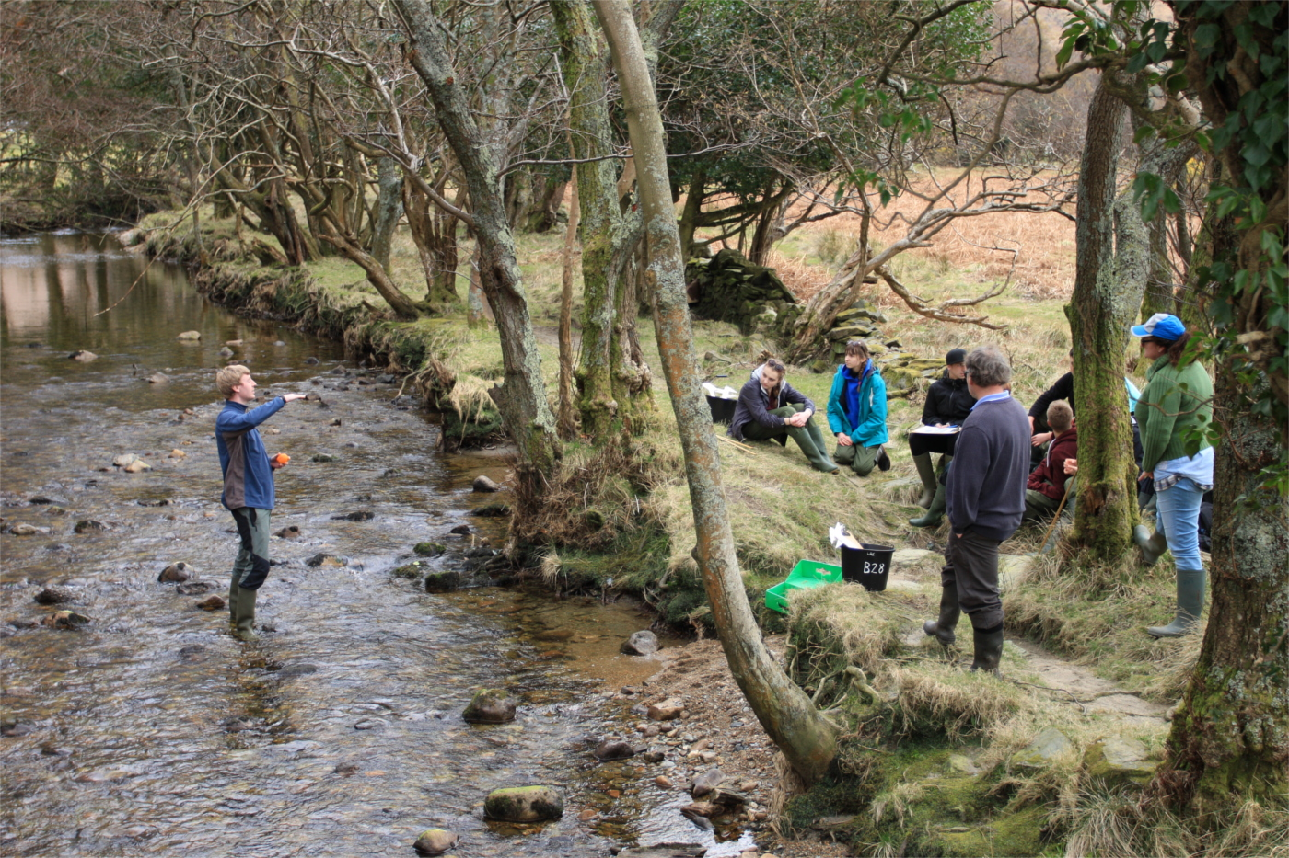
Students will use their data to calculate cross sectional area, hydraulic radius, and discharge. The drainage basin characteristics will be studied using modern techniques such as GIS software. Our expert tutors will guide the students through a range of data presentation techniques and ignite an analytical discussion comparing data. This can be backed up by statistical analysis techniques such as Spearman’s rank. Finally, students will reflect back upon their day and evaluate which of their methods worked and the pro’s and con’s of each technique.
The River Chalmadale also provides an excellent opportunity to study how physical and human environments interact in a rural setting. Students will consider industrial use of the river, rivers as possible energy source & extraction as drinking water. The river system also creates significant flooding issues in the village.

Half Day

Landscape Systems
Drainage Basins & the Hydrological Cycle

In the centre of Lochranza Village two river systems join; the Chalmadale & the Easan. Although both have a similar size of drainage basin, the discharge figures at the mouth of the two rivers is very different

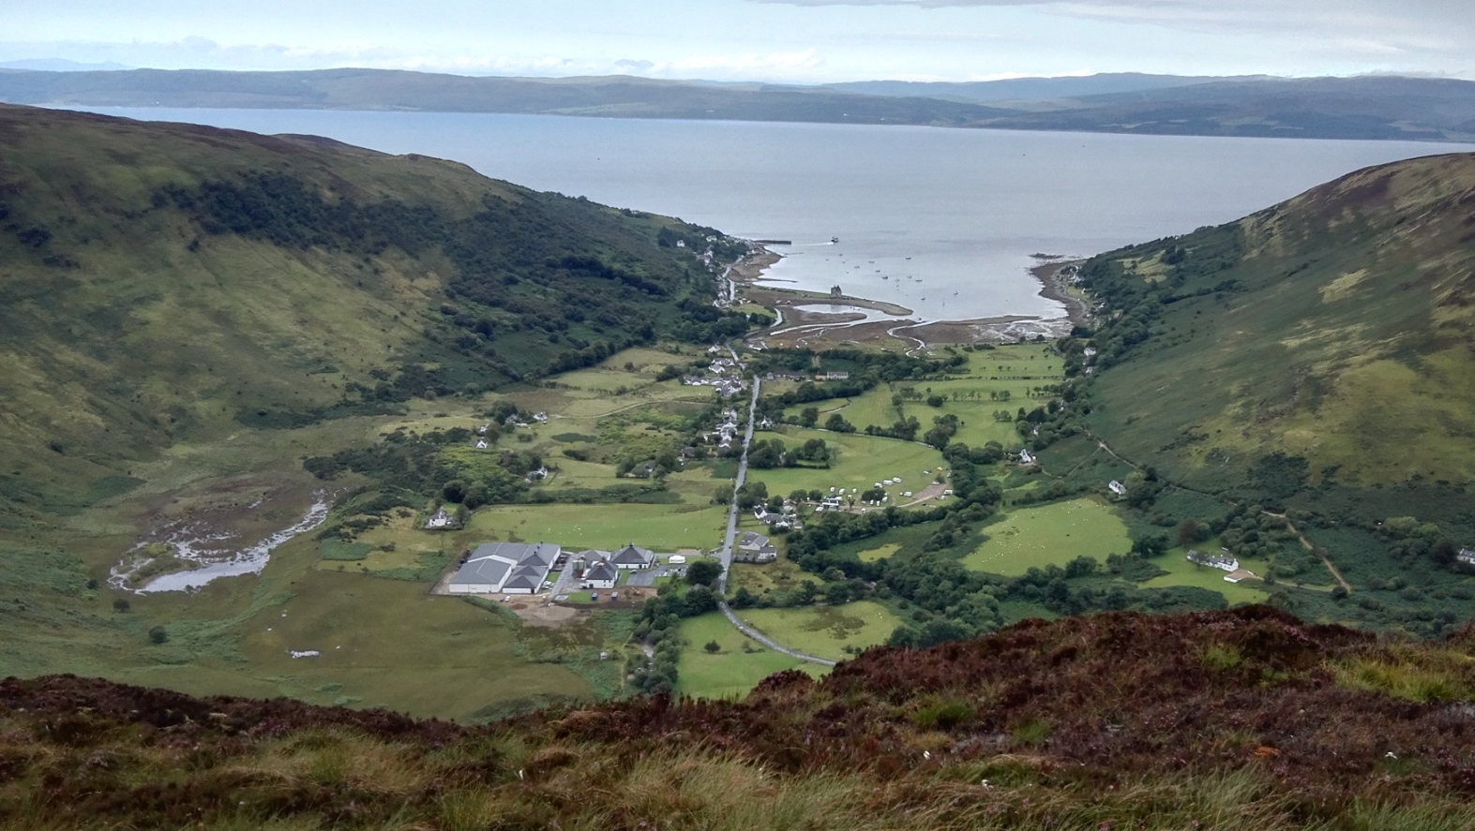
Teacher preview weekends can be made available upon request.
Half Day
Full Day

Landscape Systems
Coastal Systems and Landscapes

Overview
Arran has a great many safe & accessible coastal fieldwork locations. Coastal processes and Landscapes are studied locally in the Lochranza area & on the West coast of the island, along the stunning coastline between Machrie & Blackwterfoot. Together they make up a full day study. Coastal processes in the Lochranza area can be studied as a stand-alone half day option.
Students will conduct a long shore drift investigation, by gathering beach sediment data along a transect. The pebble size and roundness will be plotted up, allowing students to draw interpretations from the graphical representations. Beach profile analysis is included.
Many coastal landforms can be studied on a walk from Machrie to Blackwaterfoot including: headlands, bays, cave, arch, stack, stump, sand dunes and sea cliffs. Students will notice that some of these features are set away from the current high tide line, due to isostatic & eustatic change. Arran has some of the best examples of raised beaches in the UK. There are also good examples of coastal management techniques including sand trap fencing & gabions.
Evening follow up
Student will be guided through a range of data presentation techniques, and will discuss what the results show. Statistical analysis such as Spearman’s Rank, Pearson’s, Man-Whitney, and Chi square can be used to provide further evidence of any correlations. Students are encouraged to engage in debates about the meaningfulness of data, and consider the reasons behind any surprising results. Finally an evaluation of field techniques will allow students to critique their methods and aim to improve them in future.
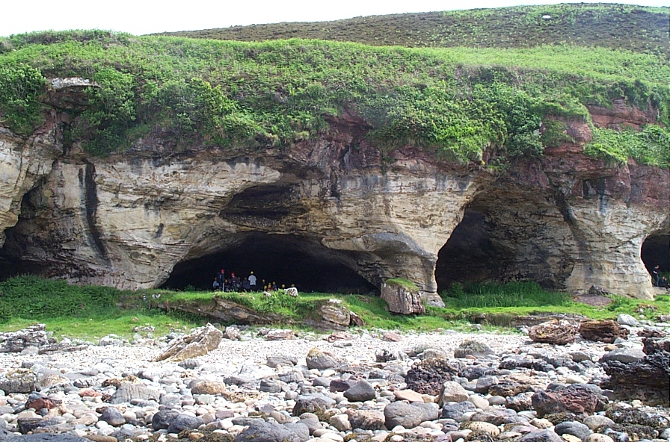

Full Day
Half Day
Landscape Systems
Cold Environments – Processes,
Landscape and change

The granite landscape of the northern mountains offers a tremendous opportunity to study an environment shaped by glacial processes. Depositional features are located in the base of the valley, while other spectacular landforms including corries, arêtes and pyramidal peaks are observed at altitude. The hanging valley of Glen Easan displays a vast selection of geographical processes and features for investigation. Glaciation, fluvial processes, weathering and various forms of mass movement have established a very unique and interesting area containing many textbook examples. Data collection in the form of till fabric analysis is used to establish the origin and method of formation of the various terraces and moraines. This forms the first part of a full day study when combined with Glen Rosa or can be used on its own as a half day study.
Glen Rosa is a text book example of a glacial valley. It provides good examples of glacial deposits and features, such as possible moraines, erratics, braided deposits and hanging valleys. As a National Trust owned area & a big tourist destination it provides an example of land uses & management in a post glacial landscape The circular route through the valley provides some of the most spectacular views on the island of the post-glacial mountain peaks.
Additional fieldwork options for glaciated landscapes:
For the more adventurous there is the option of full day walk starting at the mouth of Glen Catacol and returning via the Correin Lochain. The route covers more than 7 miles & go up to over 400m in height. It requires a reasonable level of fitness from staff & students. This option is dependent on group size, weather & the availability of qualified Mountain Leaders.

Landscape Systems
Ecosystems & The Carbon Cycle

Full Day
Half Day

Option 1: A study of heathland ecology - An initial lecture in soil science provides the background for fieldwork aimed at identifying the interrelationships between soil, vegetation and climate at different altitudes. Students will have the opportunity to gets hands on with a multitude of recording equipment whilst working their way up a hill-slope. Data presentation takes the form of a soil catena, analysis and interpretation focuses on plant adaptations.
Option 2: Atmosphere, weather and climate - Microclimate studies in Glen Chalmadale compliment an introductory lecture in atmosphere, weather and climate in Britain. Temperature, humidity, wind speed, light intensity and topographic exposure are measured using a variety of instruments. Tuition in synoptic chart interpretation enables students to prepare and present contemporary weather forecasts.
Option 3: The forest ecosystem - A study of deciduous woodland in Lochranza focuses on floral diversity / abundance, soil quality and microclimate measurements.
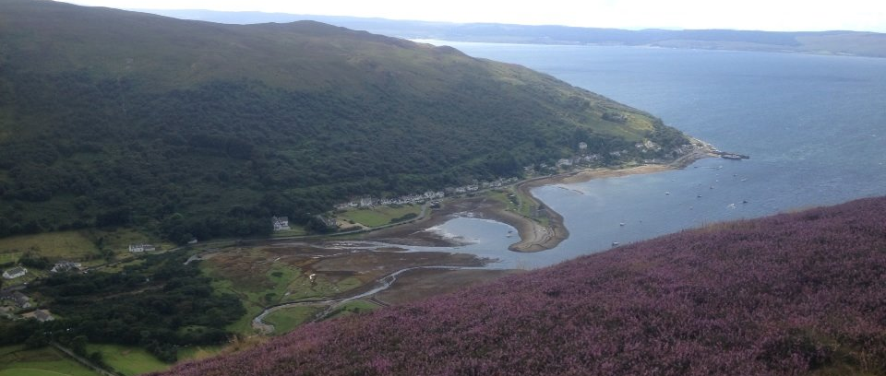
Teacher preview weekends can be made available upon request.
Full Day
Changing Places
A case study of the Isle of Arran
(Can be contrasted with your local place)

Arran provides an excellent case study setting for ‘Changing Places’. Subsistence farming pre-1800 was substituted for crofting post 1800. Primary industry has steadily been replaced by the tourist industry over the last century, which has led to radical changes in the population structure.
Fieldwork involves visiting four different settlements which together provide an overall impression of the ‘character of Arran’. Fieldwork techniques include landscape character Assessments, photo evidence for change over time, build environment surveys, ‘people’ assessments, ‘Placecheck’ & recent key projects which have resulted in change. Follow-up uses a variety of techniques to understand Arran’s character including population statistics, historical film footage, photographs, poems & music.
Students will be encouraged to continually compare and contrast the data they are collecting with the area they live in. All fieldwork & follow-up techniques used on Arran can be used in a ‘contrasting place’.
Arran provides a very interesting and unique rural case study for ‘Changing Places’ & is particularly suited to contrast with a more urban location.
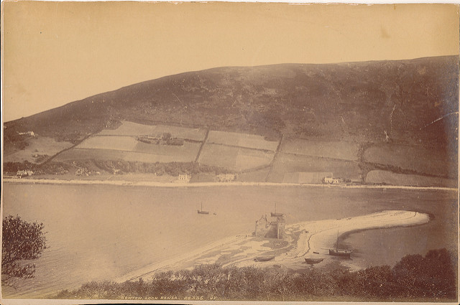

Half Day
Full Day
Changing Places
Urban Studies - Glasgow

Glasgow has undergone considerable change since World War II. Once the industrial heartland of Scotland Glasgow’s present function is dominated by the service industry. Glasgow provides an interesting case study to explore a constantly changing urban environment. In the 1980’s the city council implemented a large project to remove all council housing schemes from the city centre and re-locate them on the outskirts of the city. This allowed the city centre to be rejuvenated and compete with other leading European cities. Glasgow is now one of the most modern cities in Europe and recently hosted such events as the 2014 Commonwealth games.
Full Day - Transects in the morning between the suburbs and the CBD consider, land use zonation, service order / function and environmental quality. Specific hypotheses regarding the function of the City are assigned to groups early afternoon. A guided coach tour of the city is also an option for the afternoon, at an additional cost.
Half Day - Groups may choose to do this study on their day of departure & only carry out the morning transects.
There is an additional cost for this option of around £20 per student dependent on group size.

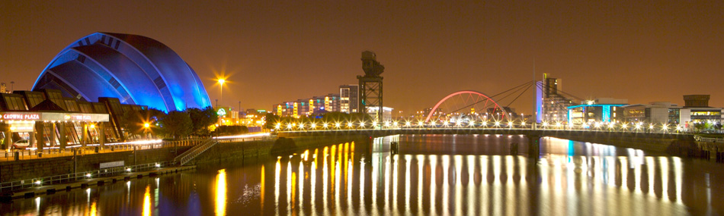

Half Day
Independent Investigation
Geographical Fieldwork Skills –
Investigation, Design and Planning

Students will be guided through the stages of a Geographical Investigation.
- Aim / objectives
- Hypothesis
- Methods
- Data collection
- Data presentation
- Analysis
- Conclusions
- Evaluation
Essential terminology and a variety of techniques provide an understanding of how to gather information in the field. Different forms of data (quantitative and qualitative), sampling methods (quadrats, random, systematic, point, stratified and plotless) and transects (line, un/interrupted, belt) are covered in theory and fieldwork. Presentation, analysis, interpretation and evaluation consolidates initial data collection. This day provides essential information for students who plan to use data gathered at Lochranza or from studies back at home to carry out an investigation. It works well as an introduction to the course.
